It we splits data into k parts. From that some part of data used for training and some for validation. It actually iterates all the data to.
Orange part is the validation set and all blue part are training set, so all the folds will become validation set and it’s loss are stored, from all loss function average will be found finally.

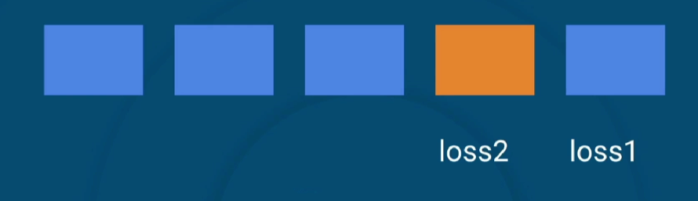

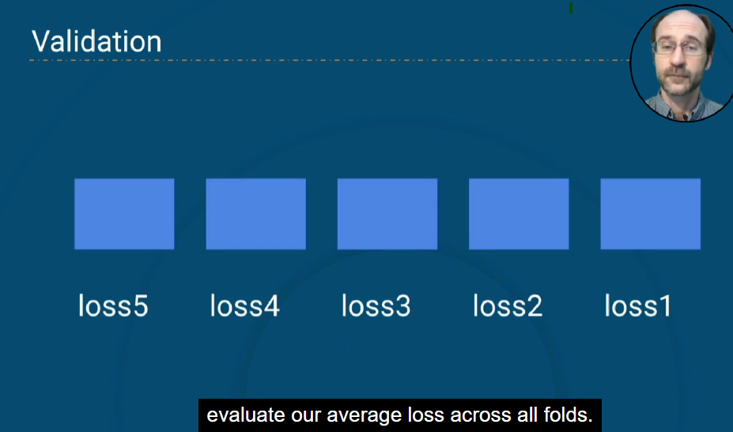

OUTPUT FOR CODING (tranfer_learning_and_kforce_cross_validation_callbacks.py)
